**ENGI 5631: Signal and Image processing in Biomedical Applications**

**MRI Laboratory: TEAM 3**

**INTRODUCTION:**

Detailed image of the brain and the brain stem can be obtained by performing Magnetic resonance imaging (MRI) of the head. It is a painless, non-invasive test. The images are created by the MRI machine by using magnetic field and radio waves. The test also referred to as cranial MRI.

When the body is placed in a strong magnetic field, such as an MRI scanner, the protons' axes all line up. This uniform alignment creates a magnetic vector oriented along the axis of the MRI scanner. MRI scanners come in different field strengths, usually between 0.5 and 1.5 tesla. An Image is computed from the [resonance](http://www.scholarpedia.org/article/Resonance) signals of which the frequency and phase (timing) contain space information. MRI is important because it is non-invasive, safe, and yields information that cannot be obtained with any other techniques. Its most common use by far is in diagnostic medicine but MRI has other applications, particularly in the oil and food industries .

**METHODS:**

**Aliasing**: The image displays a brain in profile, but since the sampling density in k-space is too low, the nose ends up in the neck and vice versa. Thus, pathology can be hidden.

**Parallel imaging**: Parallel imaging is an independent technique.

The objects need to be placed exactly on the examination table then The object will be placed into the magnet of the MRI unit and the radiologist and technologist will perform the examination while working at a computer outside of the room. When the examination is complete, the technologist or radiologist checks the images in case additional images are needed and observations are done.

**RESULTS:**

https://github.com/0678238/Nishanth-Murali

1. **Image rendering**

**(DICOMlab1)** 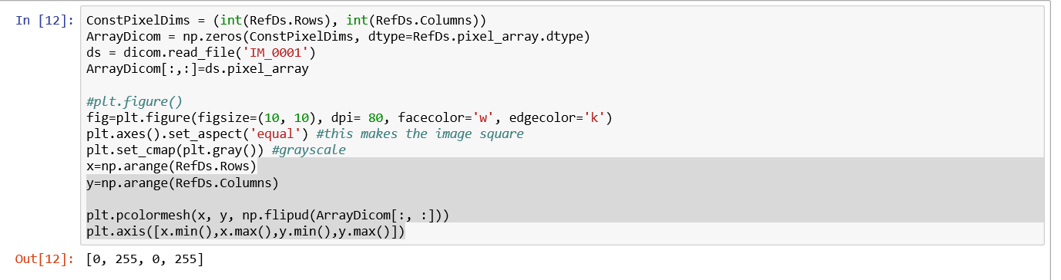

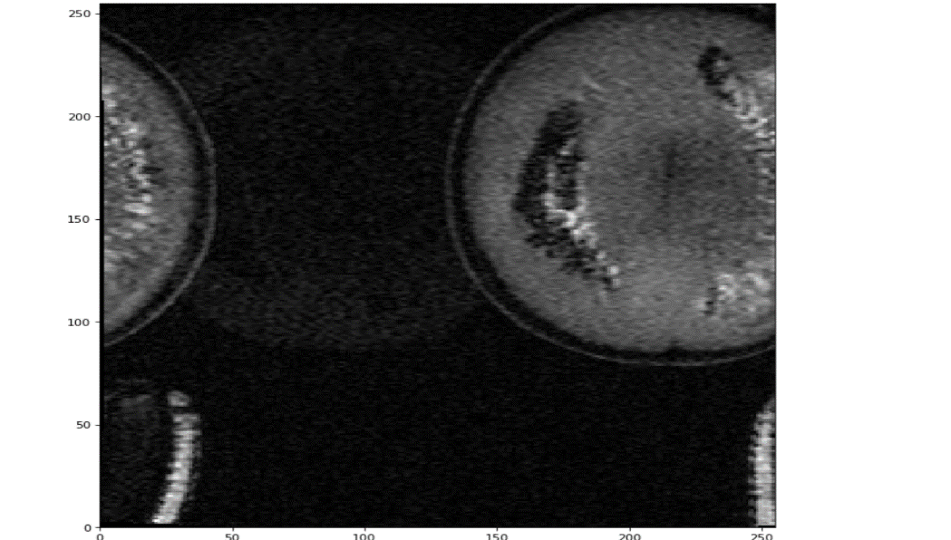

**(DICOM lab2)**

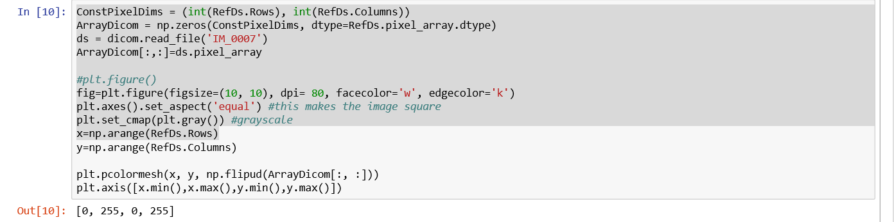

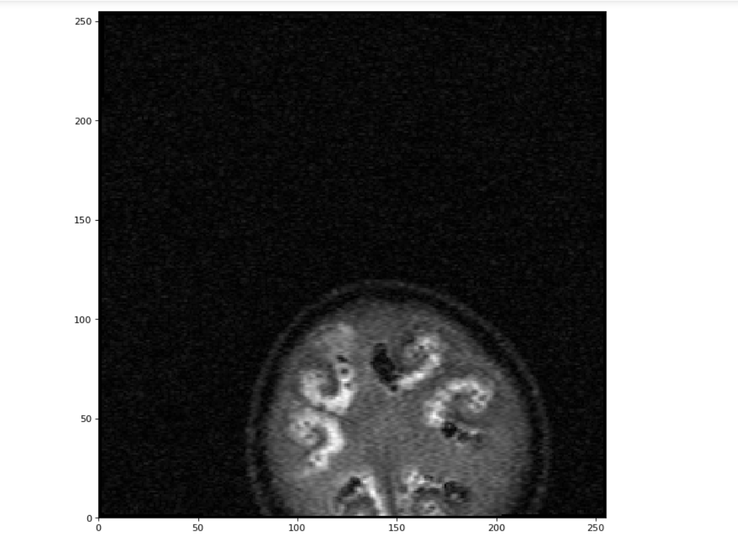

.

**MR sequence:**

1. **Spin Echo Sequence:** (0018, 9008) Echo Pulse Sequence CS: 'SPIN'

(SE) The most common pulse sequence used in MR imaging is based on the detection of a spin or Hahn echo.

It uses 90° radio frequency pulses to excite the magnetization and one or more 180° pulses to refocus the spins to generate signal echoes named spin echoes (SE).

1. **Inversion Recovery Sequence**. (0018, 9009) Steady State Pulse Sequence

CS: 'NO'

**Enumerated Values:** SPIN GRADIENT BOTH

3. (0018, 9011) **Multiple Spin Echo** CS: 'YES'

Multiple Spin Echo category of pulse sequence used to collect different lines in k-space for a single frame.

**Enumerated Values:** YES NO

1. (0018, 9018) **Echo Planar Pulse Sequence** CS: 'NO'

Echo Planar category of Pulse Sequences.

**Enumerated Values:** YES NO

Required if Image Type (0008,0008) Value 1 is ORIGINAL or MIXED. May be present otherwise. Otherwise may be present if Image Type (0008,0008) Value 1 is DERIVED and Echo Pulse sequence (0018,9008) equals SPIN or BOTH

1. (0018, 9009) **Steady State Pulse Sequence** CS: 'NO'

Required if Image Type

**3. Acquisition Matrix and Number of Pixels**

Acquisition Matrix: (0018, 1310) Acquisition Matrix (0018, 1310) US: [0, 256, 128, 0]

This is described as Dimensions of the acquired frequency/ phase data before reconstruction Number of pixels: 256*256. The word pixel means a picture element.

Acquisition matrix represents the dimensions of an image before the reconstruction whereas pixel gives the final size of the image after the reconstruction of an image.

**4. Frequency observed in Metadata**

(0018, 0084) Imaging Frequency DS: '127.753880999999'

Yes. It is the precession frequency in MHz of the nucleus that is being addressed, which can be obtained from the Larmor equation. The frequency of precession is related to the strength of the magnetic field. w = yB, where w = Larmor frequency B = Strength of the static magnetic field.

**DISCUSSION:**

* Firstly we make sure that the target is placed correctly on the acquisition table.
* Target is scanned at different positions and the data is acquired.
* By changing the parameters we can get the observations.
* Later the data is captured

**REFERENCES:**

1. Magnetic resonance imaging. Joan Dawson and Paul C. Lauterbur (2008)

2. Introduction to Magnetic Resonance Imaging Techniques. Lars G. Hanson, [larsh@drcmr.dk](mailto:larsh@drcmr.dk)

3. <https://www.healthline.com/health/head-mri>